Nominations Committee
2017 Report to Convention

This draft report reflects information received by October 4. Additional information and, hopefully, a full slate of candidates will be presented at the convention. If you are interested in standing for election to an open position please send an email to nominations@ecww.org.

With a 150-word limit, each candidate was asked to review the job description for the position and discuss how their gifts, experiences, skills, and interests would aid this work, and how they would invigorate and/or stimulate the ministry of the particular diocesan leadership group.

MEMBERS OF THE 2017 NOMINATIONS COMMITTEE: Nadine Baxter, St. Matthew/San Mateo, Auburn (Evergreen); The Rev. Lex Breckinridge, St. Thomas, Medina (Eastside); Linda Brice, St. Andrew, Tacoma (Rainier); Joan Collins, St. Barnabas, Bainbridge Island (Peninsula) Sally Farrell, Good Samaritan, Sammamish (Eastside); The Rev. Mark Miller, St. Hilda-St. Patrick, Edmonds (Sno Isle); Bill Montgomery, St. Stephen, Seattle (Be Attitudes); and Don Weir, Good Shepherd, Vancouver (Columbia).

Nominees at-a-Glance:

STANDING COMMITTEE (pg. 4)
Clerical Order | Lay Order
The Rev. Steve Danzey | Candidates TBA
The Rev. Arienne Davison
The Rev. Kendall Haynes

 | Diocesan Council (pg. 5)
Be Attitudes - Lay  Joslin Harris-Gane | Columbia - Lay  Libby Jensen | Eastside – Clergy  The Rev. Jim Eichner
Evergreen - Lay  David Coburn | Peninsula – Lay  Joan Collins | Rainier - Lay  Candidate TBA
Sno Isle – Clergy  The Rev. Drew Foisie | Willapa – Clergy  Candidate TBA

Officers of Convention (pg. 7)

Secretary | Archivist & Records Manager | Treasurer | Historiographer
Karen Gusse | Diane Wells | Barbara Fox | Br. Carle Griffin

Candidates for the Position of
4th Alternate to General Convention 2018 - Clerical Order (pg. 8)
The Rev. Eric Stelle, St. John, Gig Harbor
The Rev. Gail Wheatley, St. Andrew, Port Angeles

Brief description of each governing body/office

Standing Committee: The Standing Committee serves as a council of advice for the bishop and becomes the diocesan ecclesiastical authority in the bishop’s absence. It makes decisions about the sale, encumbrance or disposal of real property belonging to parishes of the Diocese. It interviews and makes recommendations to the bishop on candidates for Holy Orders, and the consent of the Standing Committee is required for ordination. The Standing Committee also gives or withholds consent to the election of bishops throughout the church and has judicial responsibilities in the case of clergy misconduct where the clergy or the complainant does not accept the adjudication of the bishop. By canon, no two members of the Standing Committee may be from the same congregation. Continuing members of the Standing Committee include the following: Jim Beckwith, St. Paul, Bellingham (2020); the Rev. Alfredo Feregrino, Our Lady of Guadalupe, Renton (2019); Karen McCarthy Casey, Grace, Bainbridge Island (2019); the Rev. Helen McPeak, St. Paul, Mount Vernon (2020); and Deede Woods, Church of Our Saviour, Monroe (2018).

Diocesan Council: Between Diocesan Conventions, the Council oversees the budget and program goals of the Diocese, carrying out priorities adopted by Convention. Council develops a proposed budget to be ratified by the next convention. Members assume and accept the role of public relations and goodwill toward individuals and congregations facilitating connectedness within the Diocese. Members accept assignments, work on task groups, and attend regional, committee and commission meetings as necessary. The Diocesan Council includes the bishop, and two members (one clergy and one lay) representing each of the regional ministries. Continuing members of the Diocesan Council include the following: Jan Akin, St. Benedict, Lacey (2019 – Willapa); Jamie Balducci, Epiphany Parish of Seattle, Seattle (2019 – Holy C); the Rev. Rilla Barrett, St. Stephen, Oak Harbor (2018 - Mt. Baker); Joan Collins, St. Barnabas, Bainbridge Island (2019 – Peninsula); the Rev. Doyt Conn, Epiphany, Seattle (2018 – Holy C); Linda Donato, Christ Church, Anacortes (2019 – Mt. Baker); Sally Farrell, Good Samaritan, Sammamish (2018 - Eastside); the Rev. Jedediah Fox, Redeemer, Kenmore (2019 – Be Attitudes); Bonnie Malone, St. George, Maple Valley (2019 – Evergreen); Ms. Denice Patrick, St. Hilda-St. Patrick, Edmonds (2018 - Sno Isle); the Rev. Michael Wright, St. Stephen’s, Longview (2018 - Columbia) and the Rev. Martin Yabroff, St. Matthew, Tacoma (2019 – Rainier).

Secretary of the Diocese of Olympia: The Secretary of the Diocese takes part in the planning, preparation and leadership of Convention. The secretary receives (through the convention office) all resolutions, amendments, and official written business of convention. The secretary is official signatory of Convention correspondence and is an officer of the Diocese. As an officer, the secretary serves on the Board of Directors. This is a volunteer position.

Archivist and Records Manager: The archivist and records manager is the official custodian of diocesan records and is responsible for the direction and implementation of the archives and records management program of the Diocese of Olympia. This is a part-time, paid position.

Treasurer: The treasurer of the Diocese has responsibility for the assets of the Diocese, including investments, cash, and real property. The treasurer advises the bishop on financial matters, oversees the diocesan accounting and insurance office, and serves as an officer of the diocesan corporation. The treasurer is accountable to the bishop and the diocesan convention. The treasurer also serves as a member of the Board of Directors, the James F. Hodges Diocesan Investment Fund, the Budget and Finance Committee of Diocesan Council, and convenes the Joint Finance Panel. This is a volunteer position.

Historiographer: The historiographer is responsible for creating, maintaining and continuing a history of the Diocese, including its significant leadership and events. This is a volunteer position.

2018 General Convention Alternate: The 2016 convention elected our deputies and alternates to attend the 2018 General Convention, to be held in Austin, TX. Due to a resignation, the 2017 convention will elect a 4th alternate in the clergy order.

Brief Description of General Convention: The General Convention is the governing body of The Episcopal Church, consisting of the House of Bishops and the House of Deputies meeting together every three years. The next meeting is scheduled for July 2018, in Austin, Texas. Every diocese is entitled to seat eight representatives in the House of Deputies, four clergy and four lay. The General Convention is a legislative body—some say the largest in the world—and it should not be surprising that it acts in large part like the Congress of the United States as many of its drafters were the same ‘fathers’ who designed the U.S. Constitution. It acts together to enact legislation and frequently seems submerged in paperwork (though folks are working to reduce the load. Much of General Convention work is actually accomplished in committee before legislation reaches the floor and committee assignments are avidly sought, for this is where legislation can best be influenced, amended or even cancelled. Most committee assignments are made on the basis of seniority, and as we have tended to have a stable representation of deputies our diocese has been blessed over the years with many such assignments. The down side to this system is that new faces tend to not get committee assignments. Although the deputies are expected to vote independently (and, by rule of the House, every deputy is required to be seated and voting), the deputation gets much out of caucusing and open discussion, both at the time of convention, and before.

STANDING COMMITTEE CLERICAL ORDER [one four-year term & one one-year unexpired term]

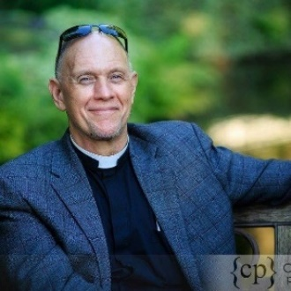
The Rev. Steve Danzey – Rector, Good Samaritan, Sammamish. My interest in serving on the Standing Committee stems from my love for the Episcopal Church and a deep desire to see it grow, thrive, and embody the Kingdom of God here in western Washington. Having
served in four parishes and three dioceses in our Church, I've gained a broad understanding of how our Church functions in various contexts, and our strengths and challenges as a Christian movement in the 21st century. I would also bring to the Standing Committee a passion for and experience in church planting, evangelism, discipleship, and theological education. Having also served as CEO of a small company before becoming a priest, my experience in administration, leadership development, and finances could be useful in supporting the work of our diocese and our bishop.

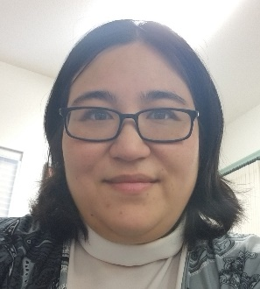
The Rev. Arienne Davison – Vicar, St. Bede, Port Orchard. Whether in the congregation or other areas of wider church life, working with colleagues in ministry to develop effective Christian leaders is my greatest passion. As Chair of the Commission on Ministry, I was honored to companion with folks in discernment for ordained ministry. As your Canon for Multicultural Ministries, I had the privilege of working with the Bishop’s Staff, governing bodies and congregations at increasing our effectiveness at intercultural ministry. I currently serve as Vicar at St. Bede, Port Orchard, trainer at the College for Congregational Development, and organize our diocesan Intercultural Competency Training Program. If elected, I would bring my love of Jesus, experience, passion and skills to bear on the important work of the Standing Committee.

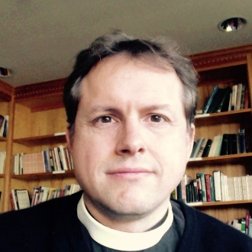
The Rev. Kendall Haynes – Rector, St. Matthew, Tacoma. Current/Previous Experience: Rector/Priest-in Charge (2013-present); Diocesan Council (2013-2016), General Convention Alternate (2015); Rainier Reg. Min. Co-Convener (2009-2011); Rector (2008-2011)

STANDING COMMITTEE LAY ORDER [one four-year term]

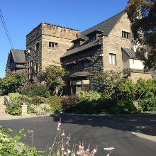
Standing Committee – not yet identified.

Standing Committee – not yet identified.

DIOCESAN COUNCIL BE ATTITUDES REGIONAL MINISTRY – LAY [one three-year term]

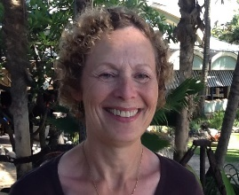
Joslin Harris-Gane – South Seattle College – Culinary Program, Christ Episcopal Church, Seattle. I have had the honor of working on the Diocesan Council for the past 3 years and am now seeking a second three-year term to continue the work of representing the Be-Attitudes region to the Diocese. I believe that I have contributed positively to the work of the Council and my goal is in the next three years, to strengthen relationships and communication between the churches in this region and the Diocese. My work experience includes the creation; understanding of; and the ability to revise budgets for business, the capability to communicate ideas and goals to motivate students and employees, and an understanding of the importance of team building and consensus in group work. I believe that one of the greatest gifts I have been given is a sense of humor, a valuable asset in any workplace or group setting. In addition, when I take on a responsibility I will accept and work hard at the tasks I have been given. I am continually revitalized and restored by God’s love and I want to contribute to the strengthening of the Episcopal Church. My desire is to offer my skills in return for what I am given everyday. I will continue to bring energy, curiosity, and purpose to the Diocesan Council.

DIOCESAN COUNCIL Columbia REGIONAL MINISTRY – LAY [one three-year term]

Libby Jensen – Good Shepherd, Vancouver.

DIOCESAN COUNCIL Eastside REGIONAL MINISTRY – CLERGY [one three-year term]

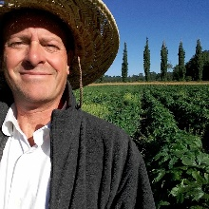
The Rev. Jim Eichner – Rector, Church of the Holy Cross, Redmond. I believe in congregations; they are the life of the diocese. Congregations, cherished and empowered, can do great work for the Gospel. I believe, diocesan staff, councils and committees, as servant leaders, do well to support congregations. I believe, infrastructures are most effective when they empower congregations. Ordained 20 years, rector 15 years, sexton 7 years. Chaired a search committee as a lay person.

DIOCESAN COUNCIL Evergreen REGIONAL MINISTRY – LAY [one three-year term]

David Coburn – St. James, Kent.

DIOCESAN COUNCIL Peninsula REGIONAL MINISTRY – CLERGY [one three-year term]

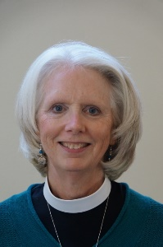
The Rev. Gail Wheatley – Rector, St. Andrew, Port Angeles. I have been canonically resident in the Diocese since the end of 2008, in the Peninsula Region and St. Andrew’s Port Angeles all that time. I am pleased and honored to be nominated to serve as the clergy representative from our region to Diocesan Council. I am also grateful for the videoconferencing center housed at St. Andrew's which will make participation easier if I am unable to make the drive. I have heard it said that if you want to know what’s going on in the diocese, serve on Council!
I will serve God, St. Andrew's and St. Swithin's, the region and the diocese to the best of my ability.

DIOCESAN COUNCIL Rainier REGIONAL MINISTRY – LAY [one three-year term]

Rainier – not yet identified.

DIOCESAN COUNCIL Sno Isle REGIONAL MINISTRY – CLergy [one three-year term]

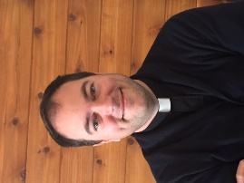
The Rev. Drew Foisie – Vicar, St. Aiden, Camano Island. I appreciate the opportunity to run for Diocesan Council. Stewardship, and an expanding theology of stewardship, has been a growing part of my ministry over time. I see budgets as not only spending plans but also theological statements. I bring a passion for continuing to see the gifts and abundance of God reflected in our governance.

DIOCESAN COUNCIL WILLAPA REGIONAL MINISTRY – CLergy [unexpired two-year term]

Willapa – not yet identified.
SECRETARY OF THE DIOCESE OF OLYMPIA

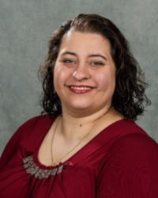
Karen Gusse – Senior Business Process Analyst for the Boeing Corporation, and a consultant with the Diocesan Congregational Consulting Network; member of St. James, Kent. I am called to support the work of the Diocese of Olympia as the Secretary to Convention. This position serves as a member of the Board of Directors, where I will use my gifts and skills developed in business to help guide the ministry and vision of the Diocese. I am a two-time prior member of the vestry at St. James, a co-leader of young adult ministry and an active part of our music ministry. I graduated from the diocesan College for Congregational Development and am now working as part of the Consultant Network. I look forward to learning from the other members and being able to share my gifts.

ARCHIVIST AND RECORDS MANAGER

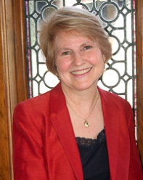
Diane Wells – Archivist and Records Manager for the Diocese of Olympia; member of Messiah Lutheran Church, Auburn. I’ve had the privilege of serving as your diocesan Archivist and Records Manager since 1994 and I’m more convinced than ever of the importance of this position. My goal continues to be to provide the diocese and its congregations, ministries and institutions with the highest possible level of archival and records management expertise and service. A current example of this is the digitization of our Refugee Resettlement case files - nearly 7,000 files representing almost 20,000 refugees who have been served by our Refugee Office. I participate in professional organizations such as the Society of American Archivists, the National Episcopal Historians and Archivists, and the Episcopal Archivists an advisory group to the Archives of the Episcopal Church. I have Masters Degrees in History and Library Science, a Certificate in Records Management and I am a Certified Archivist.

TREASURER

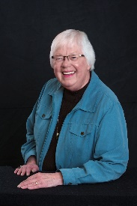
Barbara A. Fox – Retired escrow officer/limited practice officer; member of St. John, Kirkland From Philippians 4:19: "And my God will meet your needs according to his glorious riches in Jesus Christ”, which he has for the Diocese and I wish to continue my stewardship of these riches in the year to come.

HISTORIOGRAPHER

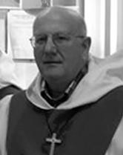
Br. Carle Griffin, OCP. – Retired; member of St. Mark’s Cathedral, Seattle. Have researched the Episcopal Church in Western Washington (1850 - 2007) for years as diocesan historiographer. I plan to finish a draft of the history by 2019 and will post a new brief version on the diocesan website this year.

Alternate TO 2018 GENERAL CONVENTION - CLERICAL

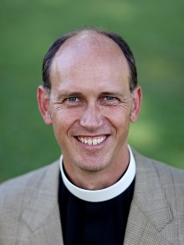
The Rev. Eric Stelle – Rector, St. John, Gig Harbor. Currently co-chair of our diocesan Liturgy & Arts Commission, I am especially interested in attending the General Convention to stay abreast of the work of the Standing Commission on Liturgy and Music. I would also like to experience the liturgies during convention and see if can contribute to the work of our commission (to say nothing of the desire simply to see The Episcopal Church at work).

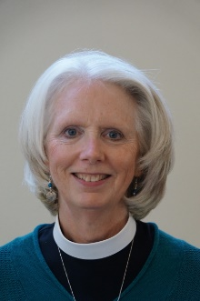
The Rev. Gail Wheatley – St. John, Gig Harbor.

